Coaching Association of Canada

2018-2019 Annual Report

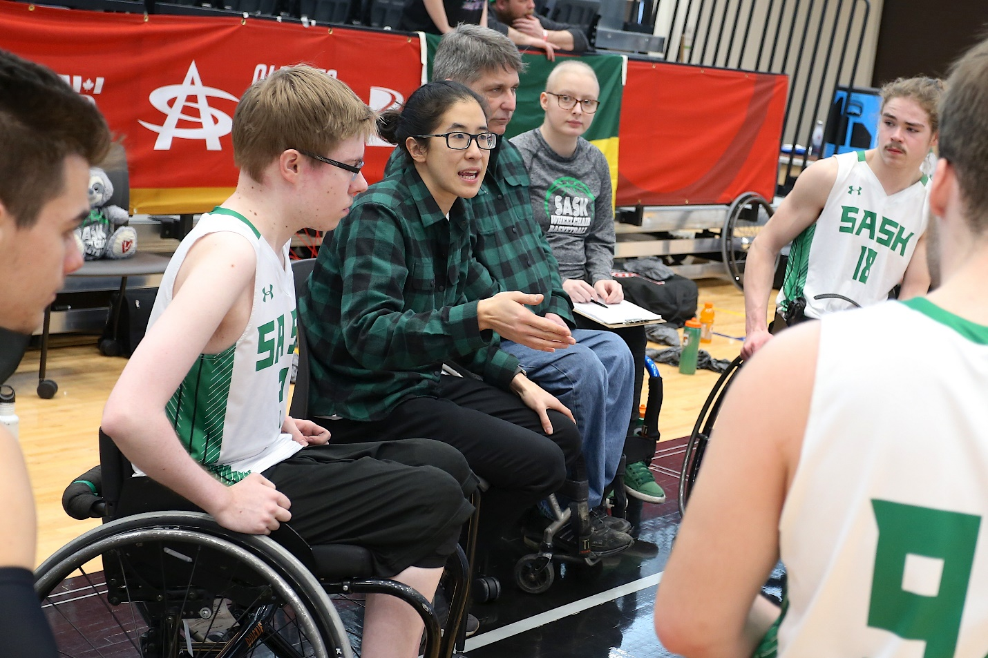

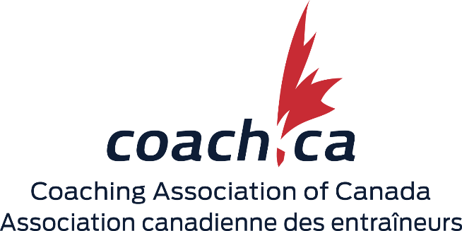
Contents
Who We Are 5
Our Mission 5
2018 - 2022 Strategic Plan 5
Key Performance Indicators 6
NCCP Code of Ethics 6
Fiscal Year 2018-19 at a Glance 7
Message from the Chair of the Board of Directors and the CEO 8
National Coaching Certification Program Partners in Coach Education 9
COACHING EDUCATION 10
Supporting Lifelong Learning 10
NCCP Highlights - Diversity and Inclusion 10
Supporting Master Coach Developers 10
NCCP Highlights - NCCP Development 11
NCCP Delivery 12
NCCP Events 12
Partnerships to Develop High Performance Coaches 12
Revised Multi-sport Modules 12
Enhancing the Value of the NCCP Advanced Coaching Diploma 13
Five-Year NCCP Forecast 13
COACHING LEADERSHIP 14
Diversity and Inclusion 14
Grants and Partnerships 14
Coaching Enhancement 14
University Mentorship and Apprenticeships 14
Indigenous Coaching 15
National Coaches Week 15
Petro-Canada Sport Leadership sportif 15
Petro-Canada Sport Leadership Awards Gala 16
2018 Partners Congress 16
CAC by the Numbers 17
IT Strategy and Renewal 17
COACHING PROFESSION 18
ChPC Model Review 18
Commonwealth Games and Canada Games Support 18
Responsible Coaching Movement Champions 18
Safe Sport Summits 19
ORGANIZATIONAL EXCELLENCE 20
International Programs 20
Best-in-Class Employee Experience 20
Organizational Research Strategy 20
Project Pulse Update 20
Corporate Partnerships 20
Revenues and Expenditures 22
Revenues 22
Expenditures 22
Board of Directors 23
CAC Staff 24
CAC Sport Partners 27
National Sport Organizations 27
Provincial/Territorial Coaching Representatives 29
Canadian Olympic and Paralympic Sport Institutes 29
National Multi-sport Service Organizations 29
Provincial/Territorial Aboriginal Sport Bodies 30

Who We Are
The Coaching Association of Canada (CAC) unites stakeholders and partners in its commitment to raising the skills and stature of coaches, and ultimately expanding their reach and influence. Through its programs, the CAC empowers coaches with knowledge and skills, promotes ethics, fosters positive attitudes, builds competence, and increases the credibility and recognition of coaches.

Our Mission
To enhance the experiences of all athletes and participants in Canada through quality coaching.

2018 - 2022 Strategic Plan
The CAC's four-year strategic plan includes Strategic Imperatives, Key Performance Indicators, the National Coaching Certification Program (NCCP) Code of Ethics, and Organizational Enablers.

Strategic Imperative 1: Coach Education
- To create, deliver, and promote excellence in education and lifelong learning to benefit the NCCP partnership.

Strategic Imperative 2: Coaching Leadership
- To grow the value and influence of coaching throughout society.

Strategic Imperative 3: Coaching Profession
- Coaching Profession: To enhance and build the profession and safe sport practices in the best interest of the public.

Strategic Imperative 4: Organizational Excellence
- To mobilize and align the CAC's resources, services, and leadership capacity.

Key Performance Indicators
In 2019-20, the CAC will gather baseline data for these KPIs, which will help the organization measure its performance against its Strategic Imperatives.

- Partner Satisfaction: More than 75% of CAC's NCCP Partners are satisfied with CAC's responsiveness, innovation, and impact of our leadership.
- New Coach Diversity: Increase the diversity across the 60,000 new coaches each year and enable existing coaches to be more inclusive.
- Sustainable Delivery Capacity: CAC's NCCP Partners have the delivery capacity to meet 90% of demand.
- Embedding ProCoach and Safe Sport: The profession of coaching and Safe Sport practices are entrenched within the majority of sport system partners.
- Team Belief in Impact: 95% of the CAC Team (board and staff) report a belief that the collective contributions of the organization are significantly and positively impacting coaching in Canada.
- Women's Equity: Increase participation in the NCCP, apprenticeship, and mentorship programs by 5%.

NCCP Code of Ethics
The NCCP Code of Ethics reflects the fundamental values of safety, responsible coaching, engaging in relations with integrity, respecting athletes, and honouring sport.

These values are expressed as five core ethical principles:
- Athlete and Participant Health and Safety
- Responsible Coaching
- Integrity in Relations with Others
- Respect
- Honouring Sport

Organizational Enablers:
- One Culture
- Invest in People
- Transformative Technology
- Incite Insight

Fiscal Year 2018-19 at a Glance
The CAC closed the year having marked significant progress and many achievements across all elements of its Strategic Plan. For example:

- Partner Satisfaction: Partners rated their satisfaction with us at 85.7%, surpassing our annual target of 75% and up from 78.4% in the previous year.

- NCCP Coach Education: We continued our work to revise and release five product modules to be released this fiscal year in three media formats. We made three modules free during National Coaches Week and saw a 450% increase in completions over the previous year.

- Transformative Technology: We completed our migration to the cloud, which will increase our scalability and further strengthen our data security and privacy capabilities. We also migrated the first six NSOs to our Learning Management System (LMS), a process we will continue in the coming years.

- Event Delivery: We held a successful Partners Congress and hosted our annual Petro-Canada Sport Leadership sportif conference, where 91% of attendees reported being either satisfied or very satisfied with their experiences.

- Diversity and Inclusion: We created a new position focusing on diversity and inclusion and secured a federal grant to develop eLearning modules on preventing gender-based violence in sport.

- Coaching Profession: We led a series of Provincial / Territorial summits on Safe Sport, to culminate in a national summit in May 2019. Also, we retooled the Chartered Professional Coach (ChPC) brand to be more intuitive and relevant.

- Brand Equity: We developed and implemented an NCCP Brand Policy and Guidelines following consultations with partners and stakeholders.

Message from the Chair of the Board of Directors and the CEO

Pride, Progress, Performance
We started our refreshed four-year strategic journey in fiscal year 2019. As you read the FY 2018-19 At a Glance, you will be proud of what we accomplished in 365 days. Our quest for innovation and simplification drove us to refine, improve, and create tools and experiences that better serve our partners, coaches, employees, and the sport community.

Looking ahead to what we aim to achieve in FY 2019-20 is exciting - and a bit daunting. Our country consists of diverse peoples, cultures, and languages. Diversity and inclusion is top-of-mind. Safe Sport is top-of-mind. Advancing the quality and the content of the National Coaching Certification Program (NCCP) is top-of-mind.

Our beliefs in One Culture, Investing in People, Transformative Technology, and Inciting Insight are also of great importance and can enable us to make the best decisions in the face of such exciting opportunities and challenges to influence and shape the coaching community in Canada.

We will also need to make the best decisions in terms of fiscal responsibility. We should all be proud of the belief our partners and sport community have in us. This is evident in the increasing number of requests for involvement, input, participation, and thought leadership.

In FY 2019-20, we must balance asks against resources and strive to meet and exceed partners' expectations, while also demonstrating value and aligning decisions to the Government of Canada's priorities of Safe Sport, gender equity, governance, and organizational excellence.

We are exceedingly proud of the team and our successes at the CAC. The passion, commitment, effort, and results we have shown continue to far exceed anything we could truly wish for. The team is outstanding, and we are honoured to continue to be at the helm of such an incredible organization.

Paul Carson
Chair, Board of Directors
Coaching Association of Canada

Lorraine Lafrenière
Chief Executive Officer
Coaching Association of Canada

National Coaching Certification Program Partners in Coach Education
The National Coaching Certification Program is a collaborative program of the Government of Canada, provincial/territorial governments, national/provincial/territorial sport organizations, and the Coaching Association of Canada.

- Alberta Sport Connection
- viaSport British Columbia
- Sport Manitoba
- Newfoundland and Labrador
- New Brunswick
- Sport North Federation
- Nova Scotia
- Nunavut
- Ontario
- Prince Edward Island Health and Wellness
- Québec
- Coaches Association of Saskatchewan
- Yukon Community Services, Sport and Recreation Branch

The programs of this organization are funded in part by the Government of Canada.

COACHING EDUCATION

Through its Coaching Education Programs, the CAC works to achieve:
- Continuous improvement in programs and services through coach learning and systems expertise
- Meaningful partnerships to impact coach knowledge and behaviour
- Increased access through platforms and innovation beyond the classroom

Supporting Lifelong Learning
To support the CAC philosophy of Lifelong Learning, the organization created new partnerships and nurtured ongoing ones to provide new and meaningful professional development opportunities for coaches. The Locker now recognizes several new modules including Keeping Girls in Sport (developed by Canadian Tire Jumpstart Charities, CAAWS, and the CAC), Commit to Kids for Coaches (created by the Canadian Centre for Child Protection) and many new modules from Sport for Life that address physical literacy, diversity and inclusion, and Indigenous culture training.

NCCP Highlights - Diversity and Inclusion
In recognition of Canada's diverse population, the CAC engaged an external organization to conduct a diversity and inclusion audit to assess current NCCP development and delivery practices. Following a discussion of the results, the NCCP Delivery Advisory Committee developed five key themes or strategies to make the NCCP more accessible to more coaches across Canada. Further, the CAC is building an innovative direction to deliver NCCP multi-sport modules (MSMs) that will better inform partners of revisions.

Supporting Master Coach Developers
Supporting the development of the Master Coach Developer workforce to deliver the NCCP is a continued priority. To that end, the organization placed considerable emphasis on the workforce that supports coach evaluation and certification. The CAC hosted an NSO Evaluation Summit, at which research was presented on the barriers to and facilitators of coach certification. Emerging priorities - including strategies to augment the coach evaluator workforce - were also identified. Further, the CAC supported 22 National Sports Organizations (NSOs) in the development of their Master Coach Developers programs.

NCCP Highlights - NCCP Development
The CAC continued to work with its partners in the development of their NCCP. In the past year, a number of National Sport Organizations (NSOs) moved towards developing their Competition contexts. Below is a list of NSOs that met Conditional Approval (CA) or Final Approval (FA) status.

Competition - Introduction
- Gymnastics Canada - Artistic Discipline (FA)

Competition - Introduction, Advanced Gradation
- Gymnastics Canada - Artistic Discipline (FA)

Competition - Development
- Boxing Canada (CA)
- Gymnastics Canada - Artistic Discipline (CA)

Competition - Development, Advanced Gradation
- Karate Canada (CA)
- Shooting Federation of Canada (CA)

Competition - High Performance
- Judo Canada (CA)
- Karate Canada (CA)
- Shooting Canada (CA)
- Ski Jumping Canada (CA)

NCCP Delivery
Number of trainings achieved per NCCP stream:
- Community Sport: 26,067 coaches
- Competition: 12,575 coaches
- Instruction: 14, 271 coaches
- Total: 52,913 coaches trained!

NCCP Events
- Total NCCP events (courses, workshops, and evaluations): 35,073
- New NCCP Coaches: 65% male, 35% female

60,266 New Sport-specific coaches entered into the locker:
- Yukon: 130
- Northwest Territories: 94
- Nunavut: 39
- British Columbia: 8,572
- Alberta: 7,035
- Saskatchewan: 3,645
- Manitoba: 3,215
- Ontario: 25,519
- Québec: 6,510
- New Brunswick: 1,405
- Nova Scotia: 2,614
- Prince Edward Island: 433
- Newfoundland and Labrador: 1,055

Partnerships to Develop High Performance Coaches
The CAC continued to work with OTP, COC, CPC, and Sport Canada to better define the NCCP High Performance coach context and develop a model of coach development in alignment with Canada's Coaching Enhancement Program. Collaboration with the Canadian Olympic and Paralympic Sport Institute (COPSI) Network to harmonize the evaluation for NCCP Competition-Development Advanced Gradation and NCCP High Performance contexts with the Advanced Coaching Diploma (ACD) created a clearer model for NSOs to develop their NCCP coach programs. Two NSO workdays and enhanced funding helped four NSOs receive approval for their programs.

Revised Multi-sport Modules
The CAC revised five NCCP multi-sport modules (MSMs) in 2018. As part of this work, the organization developed NCCP Sport Nutrition into an eLearning module and updated NCCP Make Ethical Decisions to better support coaches in legal situations and reflect the Rule of Two. Further, the CAC revised the NCCP Planning a Practice, NCCP Design a Basic Sport Program, and NCCP Developing Athletic Abilities modules to be more closely aligned with each other.

Enhancing the Value of the NCCP Advanced Coaching Diploma
The CAC conducted an extensive program assessment to identify needs and means to enhance the value of the NCCP Advanced Coaching Diploma. Results show that the program clearly enhances the quality of coaching by driving significant changes in coaching behaviours, especially with regard to critical thinking. The CAC is now developing an action plan to enhance clarity through coaches' assessments and to enhance the mentorship process.

Five-Year NCCP Forecast
The NCCP forecast was developed and implemented to help NSOs and the CAC identify gaps and needs in coach education and development across the NCCP Partnership over the next five years. Twenty-two NSOs completed the process. The results from the forecast exercise helped better inform the NSOs and the CAC of the needs and priorities to develop NSO Coach Developer workforces, as well as priority needs for future initiatives such as NSO NCCP revisions.

COACHING LEADERSHIP

Through its Coaching Leadership activities, the CAC works to:
- Influence the public to elevate the value of the coach
- Unite stakeholders through platforms and events
- Mobilize and disseminate knowledge
- Distinguish Canada internationally

Diversity and Inclusion
In July, the CAC created a new position focusing on diversity and inclusion and became an employer partner with the Canadian Centre for Diversity and Inclusion. The CAC also contracted Nanos Research to interview 15 CEOs from NSOs and Provincial/ Territorial Coaching Representatives (PTCRs) and surveyed NSO coaching administrators to identify their current initiatives, gaps, and requests for support in developing coach education materials that will engage diverse groups, including new people to Canada. Findings will determine further programming and support for 2019 and beyond.

Grants and Partnerships
The CAC received a five-year grant from the Public Health Agency of Canada (PHAC) to develop online coach education resources addressing gender-based violence in sport. The project will develop, implement, and evaluate a program to help coaches recognize, prevent, and address gender-based violence and teen-dating violence, and to promote healthy relationships in and through sport.

Elsewhere, the CAC provided grants to seven NSOs for female coach professional development, which benefitted more than 20 coaches. Further, the CAC collaborated with the COC's Game Plan program to award $1,000 NCCP grants to eight female coaches in support of their progress toward their NCCP Competition-Development and ACD coach development.

Coaching Enhancement
Through the OTP Coaching Enhancement Program, the CAC supported more than 30 next generation and high performance female coaches through individual 360-degree feedback assessments and individual professional development workshops.

University Mentorship and Apprenticeships
Twenty-three coaches participated in the Canada Games Apprenticeship Program for Women in Coaching. McGill University trained 22 mentors using the NCCP Mentorship Module and the CAC-CAAWS Female Coach Mentorship Model resources. We continued to support the Alberta Women in Sport Leadership Impact Program, which has benefited more than 500 women to-date. Finally, we published three issues of the Canadian Journal for Women in Coaching.

Indigenous Coaching
Last year, 12 apprentice coaches completed the Canada Games Aboriginal Coaching Apprenticeship Program. All are continuing their coaching pathway to high performance with continued support from their mentors. The module will inform non-Indigenous coaches about Indigenous identities and guide them to learn more through the NCCP Aboriginal Coaching Modules.

National Coaches Week
National Coaches Week, a time to celebrate coaches' tremendous positive impact on athletes and participants across Canada, took place from September 22-30, 2018. The CAC launched the week with an official proclamation from the Senate and hosted the Minister of Science and Sport and members of local NSOs at a national kick-off event.

The campaign saw tremendous engagement across the NCCP partnership and a growth in participation from community-level clubs; university and professional athletes shared their #ThanksCoach messages as well. Responses to the online campaign more than doubled compared to the previous year. In addition, more than 11,800 people used one of the campaign hashtags on Twitter and close to 7,000 coaches completed one of the free NCCP eLearning modules.

Petro-Canada Sport Leadership sportif
The CAC welcomed more than 500 sport leaders to the Westin Ottawa from November 8 - 10 for the 2018 Petro-Canada Sport Leadership sportif conference. Organized under the theme of Performance Influencers and hosted by Paralympic Swimmer Benoît Huot and gymnastics coach Taylor Pyefinch, the conference explored how the power of influence poses a unique opportunity to foster positive change in the sport system.

Conference speakers invited delegates to consider how their actions can continue to grow and have meaningful impact for their sport and organization. Speakers included Jim Moss, CEO of Plasticity Labs, and Nova Browning Rutherford, a Mindfulness Facilitator and Wellness Expert.

Further, the CAC collaborated with the Sport Information Research Centre (SIRC) to present the Sport Canada Research Initiative Conference in conjunction with Petro-Canada Sport Leadership sportif. The conference brought together members of the sport community, government, and academic researchers to learn about and discuss sport participation research.

"As my first time attending such an event, I found it to be very educational and a wonderful conduit to meet other like-minded coaches... I was very much appreciative of the recognition of coaches across this great nation of ours." - 2018 Petro-Canada Sport Leadership sportif conference delegate

Petro-Canada Sport Leadership Awards Gala
The Petro-Canada Sport Leadership Awards Gala honoured 47 coaching leaders during a glittering evening themed Palais de Glace on November 9th, in Ottawa.

Freestyle Alberta's Rob Kober, ChPC, received the Jack Donohue Coach of the Year Award. Manon Perron, ChPC, received the Geoff Gowan Award for her lifetime contribution to coaching development. They were joined by Greg Henhawk of Six Nations of the Grand River, ON, who received the Investors Group National NCCP Coach Developer Award. Tennis Canada received the Sheila Robertson Award for its outstanding contributions to coach education and professional development. The Gala also honoured 44 Petro-Canada Coaching Excellence Award recipients.

2018 Partners Congress
The CAC held its annual Partners Congress in Ottawa, June 5 - 7. The Honourable Kirsty Duncan, Minister of Science and Sport, addressed 152 delegates representing 87 organizations including NSOs, P/TCRs, MSOs, as well as representatives from Sport Canada.

In her keynote address, IBM Vice-President Beth Bell captivated attendees with inspiring messages of diversity and inclusion and energized them with her insights into user experience and innovation.

CAC by the Numbers

Social Media and Online Stats
- Twitter followers: 11,600
- Facebook Page Likes: 15,600
- Instagram Followers: 1,200
- Email Subscribers: 165,000
- The Locker Logins: 460,823
- Coach.ca Page Views: 2,764,669

Coach and Partner Services
- Calls received: 9,036
- Emails processed: 15,200

#Coach Toolkit Videos
- Tips generated per year: 24
- Impressions: 400,000 (all platforms)

NCCP Coach Breakdown
- 60,266 new sport-specific coaches in the Locker
- NCCP Making HeadWay completed: 17,487
- 534 are ChPCs
- 35% are female
- 195 have received their NCCP Advanced Coaching Diploma

IT Strategy and Renewal
The CAC undertook an exciting project to shape the future direction of technology within the coaching education community. The organization partnered with IBM and collaborated with several NSOs to arrive at a six-theme IT strategy. The strategy defines a way forward through organizational excellence, improved user experience and increased engagement, analytics, data, and infrastructure modernization.

Implementation has begun in certain key areas: revamping coach.ca, enhancing reporting capabilities, and a long-term commitment to enhancing functionality within the Locker. Further engagement continues with the sport community to define priorities of this multi-year technology journey.

COACHING PROFESSION

Through its Coaching Profession program, the CAC strives to:
- Build a professional coach community
- Champion the Responsible Coaching Movement
- Create valued services for coaches and coach employers

ChPC Model Review
The CAC Board endorsed the Chartered Professional Coach (ChPC) designation and reaffirmed it as the standard for coaching in Canada. The designation proposes a renewed model that recognizes the coaching profession at the early stages of a coaching career, at any level of coaching, and through NCCP-delivered courses and CAC-accredited post-secondary programs alike. The new ChPC program will champion athlete and coach safety on and off the field of play.

Commonwealth Games and Canada Games Support
The CAC and Coach House provided meeting space, business, administrative, technical support, and locker assistance for coaches during both the Commonwealth and Canada Games.

As part of Commonwealth Games Canada Mission Staff, the CAC hosted Coach House at the Gold Coast Commonwealth Games in Australia. The CAC also collaborated with the Canada Games Council and the 2019 Red Deer Host Committee to provide support and professional development and networking opportunities to coaches at the 2019 Canada Winter Games.

Also in Red Deer, expert sport leaders led themed nightly Fireside Chats that drew between 140 and 200 coaches over the two weeks. Coach House also ran two nightly Women in Coaching Receptions, a Community Aboriginal Coaching Module, and an Aboriginal Coaching Reception.

Responsible Coaching Movement Champions
The Responsible Coaching Movement (RCM) continued to strengthen safety and guide ethical behaviour in sport for the benefit of children, participants, and coaches. Since its launch in 2016, more than 382 organizations have signed the RCM Pledge. FY 2019 saw 214 organizations take the pledge, up 127% from last year.

By taking the pledge, these organizations have committed to implementing supportive policies and process that adhere to three key focus areas: Rule of Two, Background Screening, and Respect and Ethics Training.

Through an ongoing partnership with Canadian Centre for Child Protection, the CAC offered each NCCP Partner and RCM Champion free access to the Commit to Kids for Coaches eLearning Module. Further, Respect Group provided one free training module for each RCM Champion.

Safe Sport Summits
The sport community in Canada recognizes that a systemic culture shift is required to address and eliminate abuse, harassment, and discrimination in sport. The well-being of our athletes and children in sport must be at the forefront of all that we do.

To that end, the CAC, with additional financial support from Sport Canada, began a series of Safe Sport summits to take place in every province and territory. The summits were conducted in partnership with Provincial/Territorial Coaching Representatives (PTCRs). To complement the summits, the CAC also created an online survey that invited interested individuals to contribute their views. The CAC had conducted eight summits as of March 31, with the remaining five taking place in the spring of 2019.

The goal of the summits and survey was to contribute to the development of a universal code of conduct for sport in Canada. Each incorporated working sessions for participants to review existing codes and to develop recommendations to incorporate into a national report. The report will set the stage for the National Safe Sport Summit held in collaboration with the NSO National Safe Sport Working Group May 8 - 9, 2019.

The initial work at the summits focused on the most egregious forms of sexual violence and abuse while gaining an understanding of current pan-Canadian best practices, challenges, and opportunities for change. Steps toward a universal Code of Conduct for sport in Canada will serve as a basis for the management of abuse, discrimination, and harassment cases and as a model for common sanctioning for those who breach the code.

ORGANIZATIONAL EXCELLENCE

By focusing on Organizational Excellence, the CAC strives to:
- Relentlessly pursue the values of the Chartered Professional NCCP Coach
- Make responsive and evidence-based decisions
- Diversity its funding to enhance organizational sustainability

International Programs
The CAC provided coaching support in Bahrain, Barbados, South Africa, and with PanAm Sports (PASO). The CAC continues to partner with the Bahrain Olympic Academy on NCCP international Level 4 training. The last cohort completed its final evaluation in December, 2018, and a new agreement is in place for 2019-2020. In addition, the CAC continues to partner with South African Sports Confederation and Olympic Committee to support their coaching system development.

Best-in-Class Employee Experience
The CAC continued its commitment to providing a best-in-class experience to its employees. Staff enjoy volunteer and professional development days, and partake in and organize frequent social and sporting activities throughout the year, including a weekly 5k Friday run. The organization held professional development sessions with leadership expert Drew Dudley and formed an Employee Satisfaction Working Group to continue to drive a positive work culture.

Organizational Research Strategy
The CAC conducted extensive research and consultation to create its Research Strategy. The Strategy is to inform evidence-based decision- making and to support the NCCP Partnership. Thirty-two researchers from 12 post-secondary institutions accepted the CAC's invitation to explore ways to collaborate. The CAC is now developing an implementation plan with the support of the Canadian Council of Physical Education and Kinesiology Administrators (CCUPEKA).

Project Pulse Update
The CAC continued its work on Project Pulse, the official feedback channel for NCCP workshops. The project was rolled across eight organizations for 599 events and drew substantial subjective feedback from 5,328 participants. This feedback was provided to the respective NCCP delivery partners. The pilot program is currently being revised to deliver more value to NCCP delivery partners.

Corporate Partnerships
The CAC's corporate partners play a vital role in shaping the lives of athletes, youth, and coaches in Canada. We are indebted to these partners for their support of the CAC's coach education, development, and recognition programs.

Petro-Canada continued to recognize excellence in coaching. The company provided $550,000 to 55 coaches and their athletes through its Petro- Canada Fueling Athlete and Coaching Excellence (FACE) Program. Further, it honoured 44 coaches with its Petro-Canada Coaching Excellence Award, and drove thought leadership in sport at the Petro-Canada Sport Leadership sportif conference and Petro-Canada Sport Leadership Awards Gala. Together with the CAC, Petro-Canada has honoured more than 1,200 individual coaches since 1986.

The CAC's continued partnership with TeamSnap provided coaches with bi-monthly coaching tips and advice through the #CoachToolkit resource, which includes videos and content provided by leading high performance coaches from across Canada. Their ongoing support of the NCCP Fundamental Movement Skills module educated more than 3,287 workshop participants.

IG Wealth Management recognized NCCP Coach Developers for their passion and dedication to the NCCP with the National and Community NCCP Coach Developer Awards. They inspired and educated those new to coaching with the Get Coaching! online resource, which saw more than 5,000 sessions completed in FY 2018-19.

The CAC would like to thank IG Wealth Management for its generous support of the coaches in Canada over the course of its 26-year partnership. Over this time, the company helped develop thousands of community coaches through its Community Coaching Grants, and provided generous financial support to coach education, development, and recognition programs such as the NCCP Coach Development Awards. These initiatives brought important public recognition to coaches in Canada and acknowledged their incalculable contributions to the development and success of athletes at home and on the world stage.

The programs of this organization are funded in part by the Government of Canada.

Revenues and Expenditures
Revenues ($6,153,249) and Expenditures for fiscal year 2018-2019 for the 12-month period ending 31/03/2019:

Revenues
- Public Funds / Government of Canada: 71%
- Partners and Sales: 18%
- Petro-Canada Sport Leadership sportif Conference: 5%
- Sponsors: 4%
- International Programs: 1%
- Others: 1%

Expenditures
- Salaries and Benefits: 42%
- Education and Partnerships: 31%
- Marketing and Communications: 10%
- Administration: 7%
- Professional Coaching: 6%
- Information Technology: 3%
- International Programs: 1%

Board of Directors

Paul Carson
President
Vice-President, Hockey Development, Hockey Canada

Dany Boulanger
High Performance Coach Member
Head Coach, ARO - Club de plongeon de Québec

Janice Dawson, ChPC
National Sport Organization Member

Sara Junkin
Community Representative
Coordinator, Run Jump Throw Wheel Program - Saskatchewan Athletics

Sherry Robertson, ChPC
National Sport Organization Member
Sports Medicine, Nutritional Biochemistry, Nutrition and Dietetics RD

Manon Landry Ouellette
Provincial/Territorial Coaching and Sport Leadership Council Representative
Executive Director, Coach New Brunswick

Bill Greenlaw
Provincial/Territorial Government Representative
Executive Director Communities, Sport and Recreation, Nova Scotia Department of Health and Wellness

Lynn Boudreau
Provincial/Territorial Coaching and Sport Leadership Council Representative
Senior Sport Coordinator, Sport PEI

Greg Perreaux
Provincial/Territorial Coaching and Sport Leadership Council Representative
Executive Director, Coaches Association of Saskatchewan

Elise Marcotte
Marketing and Communications Manager, Game Plan
Olympian 2008-2012

Monica Lockie
National Sport Organization Member
National Performance Centre Director, Skate Canada

Kerry Mummery
Canadian Council of University Physical Education and Kinesiology Administrators (CCUPEKA) Representative
Dean - Faculty of Kinesiology, Sports and Recreation, University of Alberta

Daniel Domitrovic
Member-at-Large
High Performance Hockey Coach

Jason Peters
Member-at-Large
First Nation Manager, Obashkaandagaang First Nation

CAC Staff

Senior Leadership

Lorraine Lafrenière
Chief Executive Officer

Mark Donnison
Chief Operating Officer

Education Partnerships

Peter Niedre, ChPC
Director, Education Partnerships

Neale Gillespie
Senior Coaching Consultant

Gérard Lauzière, ChPC
Senior Coaching Consultant

Adam Sollitt
Coaching Consultant

Craig MacDougall
Consultant, Indigenous Coach Education and Development

Anthony Sauvé
Manager, Aboriginal Coach Development

Wayne Parro, ChPC
Senior Coaching Consultant

Marie-Pier Charest
Coaching Consultant

Jacqueline Tittley
Coaching Consultant

Chris Wellsman
Coordinator, Education Partnerships

Professional Coaching

Shelley Coolidge, ChPC
Manager, Professional Coaching Services

Marketing and Communications

Natalie Rumscheidt
Director, Marketing and Communications

Delaney Turner
Manager, Marketing and Communications

Yolande Usher
Manager, Corporate Partnerships and Marketing

Evelyn Anderson
Coordinator, Corporate Partnerships and Marketing

Pascal Villeneuve
Coordinator, Communications

Information Technology

Jeff Mees
Lead, Technology Platforms

Darren Larose
Senior Systems Analyst

Jean-Christophe Charbonneau
Developer Analyst

Dario Nujic
IT Administrator

Coach and Partner Services

Chris Patterson
Coordinator, Coach and Partner Services and Data Analysis

Jennifer White
Coordinator, Coach and Partner Services and Professional Coaching

Nathalie Joanette
Coordinator, Coach and Partner Services

Diversity and Inclusion

Isabelle Cayer
Manager, Diversity and Inclusion

Finance and Operations

Martial Desrosiers Drainville
Associate Director, Operations

Erica Bergman
Manager, Finance

Claudia Gagnon
NCCP Project and Product Manager

Vickie Lemire
Executive Coordinator

Kaymin Roorda
Coordinator, Finance

CAC Sport Partners
The CAC is a partner-driven organization that relies on the strength of its relationships to achieve its mission. The coach and sport leader development and education system in Canada is a result of the work of highly committed individuals from many different organizations who strive for coaching excellence from playground to podium.

National Sport Organizations
- Alpine Canada Alpin
- Archery Canada
- Athletics Canada
- Badminton Canada
- Ballon sur glace Broomball Canada
- Baseball Canada
- Biathlon Canada
- Bobsleigh Canada Skeleton
- Boxing Canada
- Bowls Canada Boulingrin
- Canada Basketball
- Canada Skateboard
- Canada Snowboard
- Canada Soccer
- Canadian 5-Pin Bowlers Association
- Canadian Blind Sports Association
- Canadian Cerebral Palsy Sports Association
- Canadian Fencing Federation
- Canadian Handball Association
- Canadian Lacrosse Association
- Canadian Luge Association
- Canadian Sport Parachuting Association
- Canadian Team Handball Federation
- Canadian Tenpin Federation Inc.
- Canadian Weightlifting Federation Haltérophile
- Canadienne
- Canadian Wheelchair Sports Association
- Canoe Kayak Canada
- Climbing Escalade Canada
- Cricket Canada
- Nordiq Canada
- Curling Canada
- Cycling Canada Cyclisme
- Diving Plongeon Canada
- Equine Canada
- Field Hockey Canada
- Football Canada
- Freestyle Canada
- Golf Canada
- Gymnastics Canada
- Hockey Canada
- Judo Canada
- Karate Canada
- Nordic Combined Ski Canada
- Orienteering Canada
- PGA of Canada
- Racquetball Canada
- Ringette Canada
- Rowing Canada Aviron
- Rugby Canada
- Sail Canada
- Shooting Federation of Canada
- Skate Canada
- Ski Jumping Canada
- Softball Canada
- Speed Skating Canada
- Squash Canada
- Surf Canada
- Swimming Canada
- Canada Artistic Swimming
- Table Tennis Canada
- Taekwondo Canada
- Tennis Canada
- Triathlon Canada
- Ultimate Canada
- Volleyball Canada
- Water Polo Canada
- Water Ski and Wakeboard Canada
- Wheelchair Basketball Canada
- Wrestling Canada Lutte

Provincial/Territorial Coaching Representatives
- Alberta Sport Connection
- viaSport British Columbia
- Sport Manitoba
- Coach New Brunswick
- Government of Newfoundland and Labrador, Dept. of Tourism, Culture and Recreation
- Sport Newfoundland and Labrador
- Communities, Sport and Recreation, Province of Nova Scotia
- Sport North Federation
- Government of Nunavut, Sport and Recreation Division
- Government of Ontario, Ministry of Tourism, Culture and Sport
- Coaches Association of Ontario
- PEI Department of Health and Wellness
- Sport PEI
- Ministère de l'Éducation et de l'Enseignement supérieur, SportsQuébec
- Coaches Association of Saskatchewan
- Government of Yukon, Dept. of Community Services

Canadian Olympic and Paralympic Sport Institutes
- Canadian Sport Centre Atlantic
- Canadian Sport Institute Pacific
- Canadian Sport Institute Calgary
- Canadian Sport Centre Manitoba
- Institut national du sport du Québec
- Canadian Sport Institute Ontario
- Canadian Sport Centre Saskatchewan

National Multi-sport Service Organizations
- Aboriginal Sport Circle
- Active for Life
- AthletesCAN
- Canadian Association for the Advancement of Women and Sport and Physical Activity (CAAWS)
- Canadian Centre for Child Protection
- Canadian Centre for Ethics in Sport (True Sport)
- Canadian Collegiate Athletic Association
- Canadian Council of University Physical Education
- and Kinesiology Administrators (CCUPEKA)
- Canada Games Council
- Canadian Olympic Committee
- Canadian Paralympic Committee
- Canadian Swimming Coaches and Teachers Association
- Commonwealth Games Canada
- HIGH FIVE
- International Support Program to the African and Caribbean Sport (PAISAC)
- Own The Podium
- Parachute Canada
- Physical and Health Education Canada
- Respect Group
- School Sport Canada
- Special Olympics Canada
- Sport Dispute Resolution Centre of Canada
- Sport for Life Society
- Sport Matters Group
- U SPORTS

Provincial/Territorial Aboriginal Sport Bodies
The CAC would like to thank the work of the Provincial/Territorial Aboriginal Sport Bodies for the delivery of the ACM:

- Aboriginal Sport and Recreation New Brunswick
- Indigenous Sport and Wellness Ontario
- Sport and Recreation - Government of Nunavut
- Yukon Aboriginal Sport Circle
- Aboriginal Sports Circle of the Northwest Territories
- Indigenous Sport, Physical Activity and Recreation Council - British Columbia
- Indigenous Sport Council (Alberta)
- Federation of Sovereign Indigenous Nations (Saskatchewan)
- Manitoba Aboriginal Sports & Recreation Council Inc.
- First Nations of Quebec and Labrador
- Health and Social Services Commission (FNQLHSSC) / Eastern Door and North Mi'kmaw Sport Council of Nova Scotia
- PEI Aboriginal Sports Circle
- Aboriginal Sport and Recreation Circle of Newfoundland and Labrador

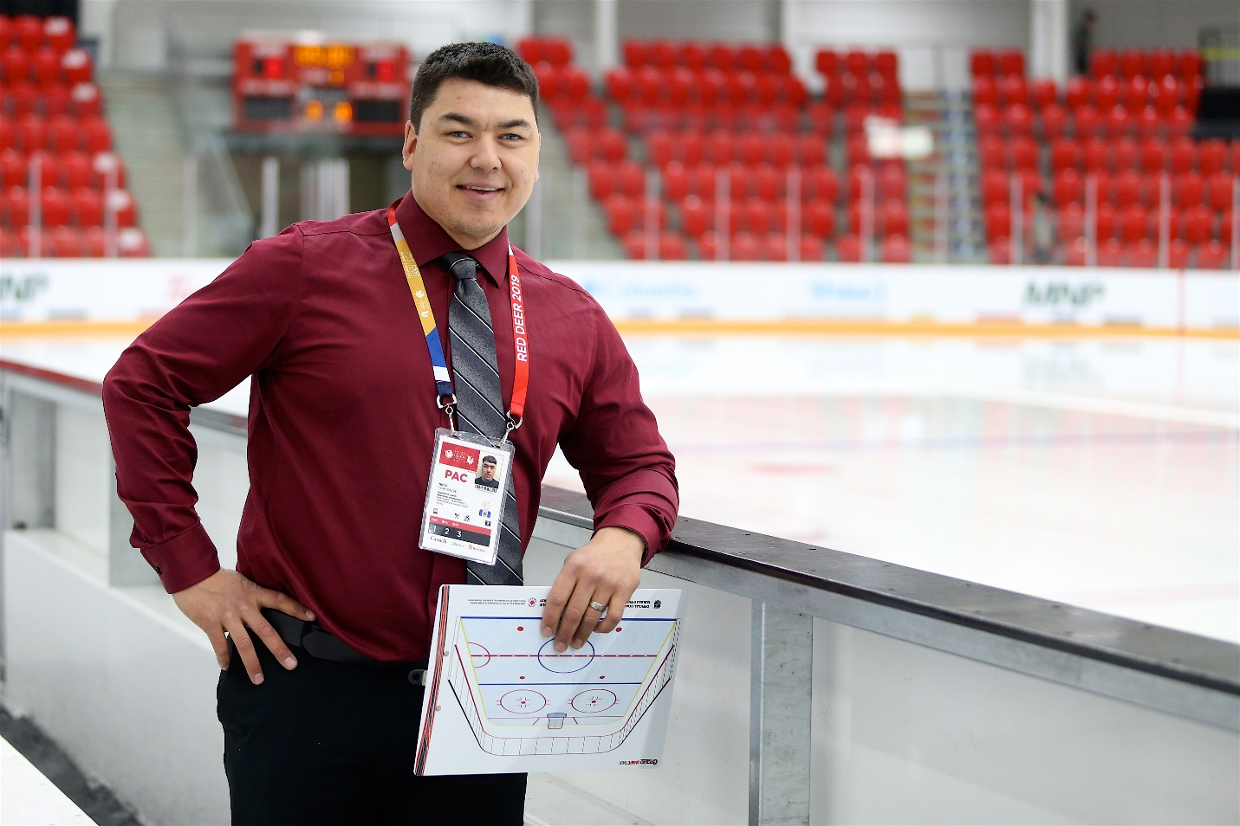
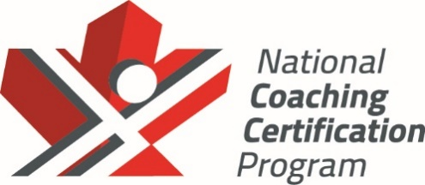
Front Cover: High Performance Wheelchair Basketball Coach Katie Miyazaki, ChPC
Back Cover: Neco Towtongie, NCCP Development 1 Certified Hockey Coach and Member of the 2019 Canada Games Aboriginal Coaching Apprentice Program

Coaching Association of Canada
House of Sport, RA Centre, 2451 Riverside Drive, Ottawa, ON K1H7X7

Photo Credits: Kevin Bogetti-Smith, CAC, Kyle Clapham, Delaney Turner

This document is copyrighted by the Coaching Association of Canada (2019) and its licensors. All rights reserved. Printed in Canada.

